Zoe Fisher MSc CSP HCPC ACPAT
INDIBA Therapist
Physio Gold registration form zoe@physiogold.net
www.physiogold.net
07833 606519

Client’s Name:  DOB:  Email: | Phone no:  GP:
Client’s address:
What3words:
Any necessary information to find site / parking etc:
Presenting condition :
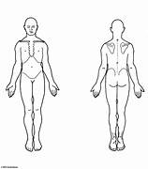

What the symptoms are:

What makes the symptoms worse:

What makes the symptoms better:

How the symptoms are at night – whether waking you and how often

How the symptoms are first thing in the morning, whether you feel older or stiff trying to get going:

History of condition

Client’s concerns, question for physiotherapist:

Previous treatments: | Investigations – eg. Xrays, ultrasound, dates and outcomes:
Medication: | Any other health conditions:

